**GLOBEGLIDER**

**AUTHOR:**

R. Abinaya (abinayar772002@gmail.com)

Department of MCA

Adhiyamaan College of Engineering (Autonomous), Hosur.

**GUIDED BY:**

Dr.D.SWAMYDOSS,MCA.,M.Tech.,Ph.D.,([hod_mca@adhiyamaan.ac.in](mailto:hod_mca@adhiyamaan.ac.in))

Department of MCA

Adhiyamaan College of Engineering (Autonomous), Hosur.

**ABSTRACT**

Globeglider Tours and Travels aims to revolutionize the travel industry by offering a comprehensive platform that integrates seamless booking experiences, personalized trip planning, and cutting-edge travel recommendations. With an emphasis on leveraging advanced AI algorithms and machine learning techniques, Globeglider seeks to redefine the way travelers discover, plan, and embark on their journeys. Our platform will provide users with a holistic travel solution, from browsing destinations to booking accommodations, transportation, and activities, all tailored to their preferences and interests.

Globeglider's mission is the commitment to enhancing the traveler's experience through innovative technology and curated content. By harnessing vast datasets and employing sophisticated algorithms, our platform will deliver personalized recommendations for destinations, activities, and experiences based on each user's unique profile and past travel behavior. Additionally, Globeglider will offer real-time assistance and support throughout the travel journey, ensuring a seamless and stress-free experience from start to finish.

## In an ever-evolving travel landscape, Globeglider stands poised to empower travelers with the tools and resources needed to make informed decisions and create unforgettable experiences. With a focus on user-centric design, technological innovation, and unparalleled customer service, Globeglider aspires to become the go-to platform for travelers worldwide, facilitating seamless exploration, discovery, and adventure across the globe.

## Globeglider sets itself apart by prioritizing sustainability and responsible tourism practices. In an era where environmental conservation and ethical travel are paramount concerns, our platform will actively promote eco-friendly travel options, support local communities, and advocate for the preservation of cultural heritage sites. Through partnerships with eco-conscious suppliers and community-based tourism initiatives, we aspire to minimize the carbon footprint of travel while maximizing positive socio-economic impacts on host destinations.

At the heart of GlobeGlider is a commitment to fostering a sense of exploration and connection among travelers. The application incorporates a user-centric approach, allowing individuals to customize their journeys based on preferences, interests, and travel goals. GlobeGlider not only streamlines the logistics of travel but also enhances the overall experience by offering curated suggestions, insider tips, and interactive maps. By combining convenience with a touch of adventure, GlobeGlider aims to empower users to embark on journeys that are not just destinations but transformative moments in their lives.

**OBJECTIVE**

GlobeGlider Tours and Travels embarks on a transformative journey with a clear set of objectives aimed at revolutionizing the tourism industry. At its core, the project endeavors to redefine the travel experience by seamlessly integrating technology, sustainability, and personalized service. With a commitment to excellence, GlobeGlider aspires to become a beacon of innovation within the global travel landscape.

The project aims to harness the power of cutting-edge technology to enhance every facet of the travel journey. By leveraging advanced data analytics, artificial intelligence, and machine learning algorithms, GlobeGlider seeks to provide unparalleled levels of personalization and customization to its customers. From curated travel itineraries tailored to individual preferences to real-time updates and assistance throughout the trip, technology serves as the cornerstone of GlobeGlider's commitment to delivering exceptional service.

In addition to technological innovation, GlobeGlider is deeply committed to promoting sustainability and responsible tourism practices. With a growing awareness of the environmental impact of travel, the project recognizes the urgent need to minimize carbon footprints and preserve the planet's natural beauty. Therefore, GlobeGlider endeavors to partner with eco-conscious vendors, implement green initiatives such as carbon offset programs, and educate both staff and customers about the importance of sustainable travel practices. By prioritizing environmental stewardship, GlobeGlider not only reduces its own ecological footprint but also sets a precedent for the industry at large.

GlobeGlider aims to foster meaningful connections and cultural exchange between travelers and the destinations they visit. In an increasingly interconnected world, the project recognizes the value of authentic experiences that promote cross-cultural understanding and appreciation. Through partnerships with local communities, immersive cultural activities, and off-the-beaten-path excursions, GlobeGlider endeavors to facilitate genuine encounters that enrich the travel experience and leave a positive impact on both travelers and host communities alike.

At the heart of GlobeGlider's objectives lies a relentless commitment to customer satisfaction and excellence in service delivery. From the moment a traveler begins planning their trip to the final farewell, GlobeGlider strives to exceed expectations at every touchpoint. Whether it's providing personalized recommendations, offering round-the-clock support, or ensuring seamless logistics, the project is dedicated to creating unforgettable moments and lasting memories for every traveler. By prioritizing customer-centricity and embracing a culture of continuous improvement, GlobeGlider sets itself apart as a leader in the travel industry, poised to redefine the standards of excellence and redefine the art of exploration for generations to come.

**SOFTWARE REQUIREMENT**

**MINIMUM REQUIREMENTS**

* Web Technology : React Js
* Frontend : React Js, bootstrap, CSS, JavaScript
* Hardware : 512 GB
* Operating System : Windows 10 and Above

**OBJECTIVES OF REACT JS**

React.js is a powerful JavaScript library designed to facilitate the development of dynamic and interactive user interfaces. At its core, the primary objective of React.js is to simplify and streamline the process of building complex UIs by breaking them down into modular, reusable components. These components encapsulate both the structure and behavior of specific parts of the user interface, promoting a modular and maintainable codebase.

One of the key features of React.js is its use of a virtual DOM (Document Object Model), which is a lightweight representation of the actual DOM in memory. By employing a virtual DOM, react can efficiently update the user interface in response to changes in data or state without directly manipulating the DOM, resulting in significant performance improvements.

Another crucial objective of React.js is to enable developers to build UIs using a declarative programming paradigm. Instead of imperatively defining the steps needed to update the UI in response to changes, developers can simply declare how the UI should look based on the current state of the application. This declarative approach not only makes the code more intuitive and easier to understand but also helps minimize bugs and improve code maintainability.

React.js also promotes the idea of unidirectional data flow, where data flows from parent components down to their children via props (properties). This ensures that the data flow within the application remains predictable and makes it easier to understand how changes in one part of the UI can affect other parts.

React.js emphasizes the concept of composability, allowing developers to compose complex UIs by combining smaller, reusable components. This approach encourages code reuse and modularity, making it easier to manage and maintain large-scale applications.React.js promotes a philosophy of "learn once, write anywhere" through its use of a component-based architecture and its compatibility with both web and mobile platforms. Developers can leverage their knowledge of React.js to build not only web applications but also mobile apps using frameworks like React Native.

The primary objective of React.js is to provide developers with a powerful and efficient tool for building dynamic and interactive user interfaces by promoting modularity, reusability, performance, and a declarative programming paradigm. By achieving these objectives, React.js has become one of the most popular choices for front-end development, empowering developers to create robust and engaging UIs across a variety of platforms.

**JAVASCRIPT**

JavaScript  (often shortened to JS) is a lightweight, interpreted, object-oriented language with [first-class functions](https://en.wikipedia.org/wiki/First-class_function), and is best known as the scripting language for Web pages, but it's [used in many non-browser environments](https://en.wikipedia.org/wiki/JavaScript#Uses_outside_Web_pages) as well. It is a [prototype-based](https://en.wikipedia.org/wiki/Prototype-based_programming), multi-paradigm scripting language that is dynamic, and supports object-oriented, imperative, and functional programming styles.

JavaScript runs on the client side of the web, which can be used to design programs on how the web pages behave on the occurrence of an event. JavaScript is an easy to learn and also powerful scripting language, widely used for controlling web page behavior. JavaScript can function as both a [procedural](https://en.wikipedia.org/wiki/Procedural_programming) and an [object oriented language](https://developer.mozilla.org/en-US/docs/Web/JavaScript/Introduction_to_Object-Oriented_JavaScript).

JavaScript supports much of the [structured programming](https://en.wikipedia.org/wiki/Structured_programming) syntax from [C](https://en.wikipedia.org/wiki/C_(computer_language)) (e.g., if statements, while loops, switch statements, do while loops, etc.). One partial exception is [scoping](https://en.wikipedia.org/wiki/Scope_(computer_science)): JavaScript originally had only [function scoping](https://en.wikipedia.org/wiki/Function_scoping) with var. ECMAScript 2015 added keywords let and [const](https://en.wikipedia.org/wiki/Const_(computer_programming)) for block scoping, meaning JavaScript now has both function and block scoping. Like C, JavaScript makes a distinction between [expressions](https://en.wikipedia.org/wiki/Expression_(computer_science)) and [statements](https://en.wikipedia.org/wiki/Statement_(computer_science)). One syntactic difference from C is [automatic semicolon insertion](https://en.wikipedia.org/wiki/Defensive_semicolon), which allows the semicolons that would normally terminate statements to be omitted.

Values are cast to numbers by casting to strings and then casting the strings to numbers. These processes can be modified by defining to String and value Of functions on the [prototype](https://en.wikipedia.org/wiki/JavaScript#Object-orientation_(prototype-based)) for string and number casting respectively.

**EXISTING SYSTEM**

GlobeGlider Tours and Travels currently operate with a traditional manual system for managing bookings, reservations, and customer interactions. This system relies heavily on paperwork, phone calls, and physical documentation, resulting in inefficiencies and potential errors.

The booking process entails customers contacting the agency via phone or visiting the office in person to make reservations. This manual approach is time-consuming and prone to errors, as staff manually record details and may overlook important information.

Managing customer information and preferences is challenging with the existing system. Customer data is stored in physical files or spreadsheets, making it difficult to access and update in real-time. This lack of centralized information leads to inefficiencies and may result in missed opportunities to personalize services for customers.

The current system struggles to provide seamless communication between customers and the agency. Customer inquiries, changes in bookings, or requests for additional services require direct communication via phone or email, leading to delays and potential misunderstandings.

The manual system poses limitations in terms of scalability and expansion. As the business grows, managing a large volume of bookings and customer data becomes increasingly complex and labor-intensive. This can hinder the company's ability to adapt to changing market demands and offer competitive services.

The absence of an integrated payment system complicates the financial aspect of the business. Payments are typically processed offline, requiring customers to visit the office or make bank transfers, which can be inconvenient and time-consuming for both parties. Overall, while GlobeGlider Tours and Travels have been operating successfully with the existing system, there is a pressing need to transition to a more efficient and technologically advanced solution to streamline operations, enhance customer experience, and facilitate future growth.

**PROPOSED SYSTEM**

The proposed system will feature a robust online booking platform accessible through both desktop and mobile devices. Customers can easily browse through a wide range of travel packages, accommodation options, transportation services, and activities. The platform will offer secure payment gateways, allowing users to book their desired services with ease. Additionally, an intuitive interface will enable users to customize their itineraries according to their preferences, including destinations, dates, and budget constraints.

The system will incorporate a 24/7 customer support service to assist travelers at every stage of their journey. Through live chat, email, and phone support, users can receive instant assistance with booking inquiries, itinerary modifications, and emergency situations. Moreover, the system will utilize chatbots equipped with natural language processing capabilities to address common queries, provide trip updates, and offer personalized recommendations in real-time, enhancing efficiency and responsiveness.

To streamline operations and enhance collaboration among stakeholders, the proposed system will feature an integrated travel management system. This comprehensive platform will facilitate seamless communication and coordination between travel agents, tour operators, accommodation providers, and transportation companies. By centralizing data and automating workflows, the system will optimize resource allocation, minimize errors, and improve overall efficiency in managing bookings, reservations, and logistical arrangements.

**MODULES**

* User Profile
* Trip Planning
* Navigation and Maps
* Booking and Reservation
* Review and Feedback

**MODULE DESCRIPTION**

**USER PROFILE:**

The User Profile module in GlobeGlider is like your personal travel passport within the platform. It's where you create and manage all the details that make your travel experience unique to you. Think of it as your digital suitcase where you pack all your preferences, from your name and contact information to your favorite destinations and travel habits.

Once your profile is set up, you can update it anytime. If you change your email address or want to add a new favorite destination, you can easily do it from your profile settings. Plus, your profile helps GlobeGlider provide personalized recommendations and offers based on your travel history and preferences. It's like having a travel agent who knows exactly what you like and can suggest the perfect trip just for you. So, whether you're a frequent flyer or a first-time traveler, your GlobeGlider user profile is your key to unlocking a world of personalized travel experiences.

.

**TRIP PLANNING:**

The Trip Planning module in GlobeGlider is your virtual travel assistant, designed to make planning your next adventure a breeze. It's like having a seasoned travel expert at your fingertips, ready to help you craft the perfect itinerary tailored to your preferences and needs. Whether you're jet-setting across the globe or embarking on a weekend getaway, this module is your go-to tool for organizing every aspect of your trip.

**NAVIGATION AND MAPS:**

The Navigation and Maps module in GlobeGlider acts as your digital compass, guiding you through every twist and turn of your journey with precision and ease. It's like having a reliable navigator in the palm of your hand, ensuring that you never lose your way, whether you're exploring a bustling city or navigating remote wilderness. This module harnesses cutting-edge mapping technology and GPS functionalities to provide you with accurate, real-time navigation assistance, empowering you to travel confidently and efficiently to your desired destinations.

**BOOKING AND RESERVATION:**

The Booking and Reservation module in GlobeGlider serves as your virtual concierge, streamlining the process of securing accommodations, transportation, and other travel services with just a few clicks. It's like having a dedicated booking agent at your service, helping you find the perfect hotel, flight, rental car, or activity to suit your preferences and budget. This module offers a user-friendly platform where you can browse, compare, and book a wide range of options to create your ideal travel itinerary hassle-free.

**REVIEW AND FEEDBACK:**

The Review and Feedback module in GlobeGlider acts as a vital communication channel between users and the platform, facilitating the exchange of experiences, opinions, and suggestions to enhance the overall travel experience. Think of it as a virtual suggestion box where users can share their thoughts, provide ratings, and offer feedback on various aspects of their travels, from accommodations and transportation to activities and destinations.

**SCREENSHORTS:**

LOGIN SCREEN:

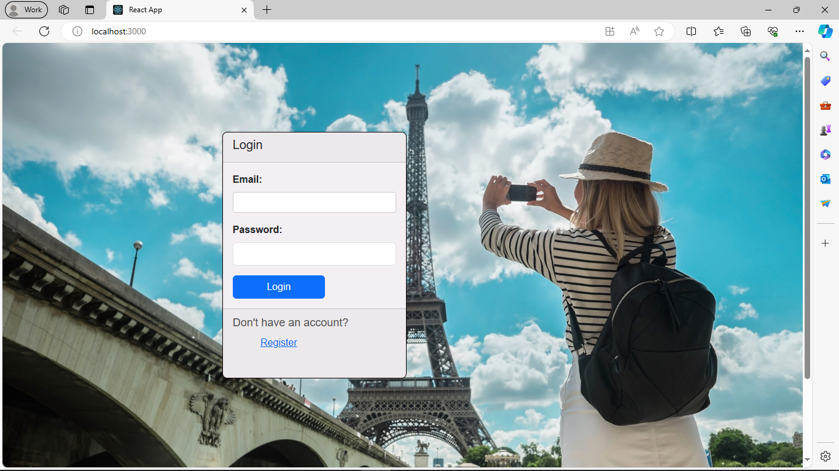

USER PROFILE:

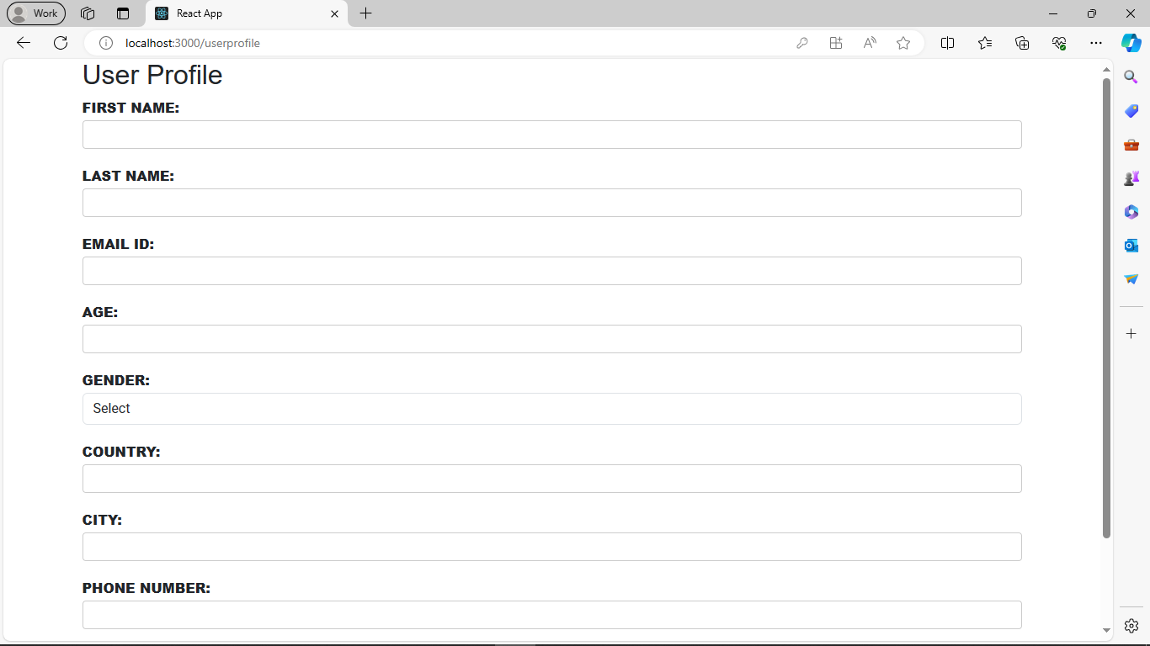

HOME PAGE:

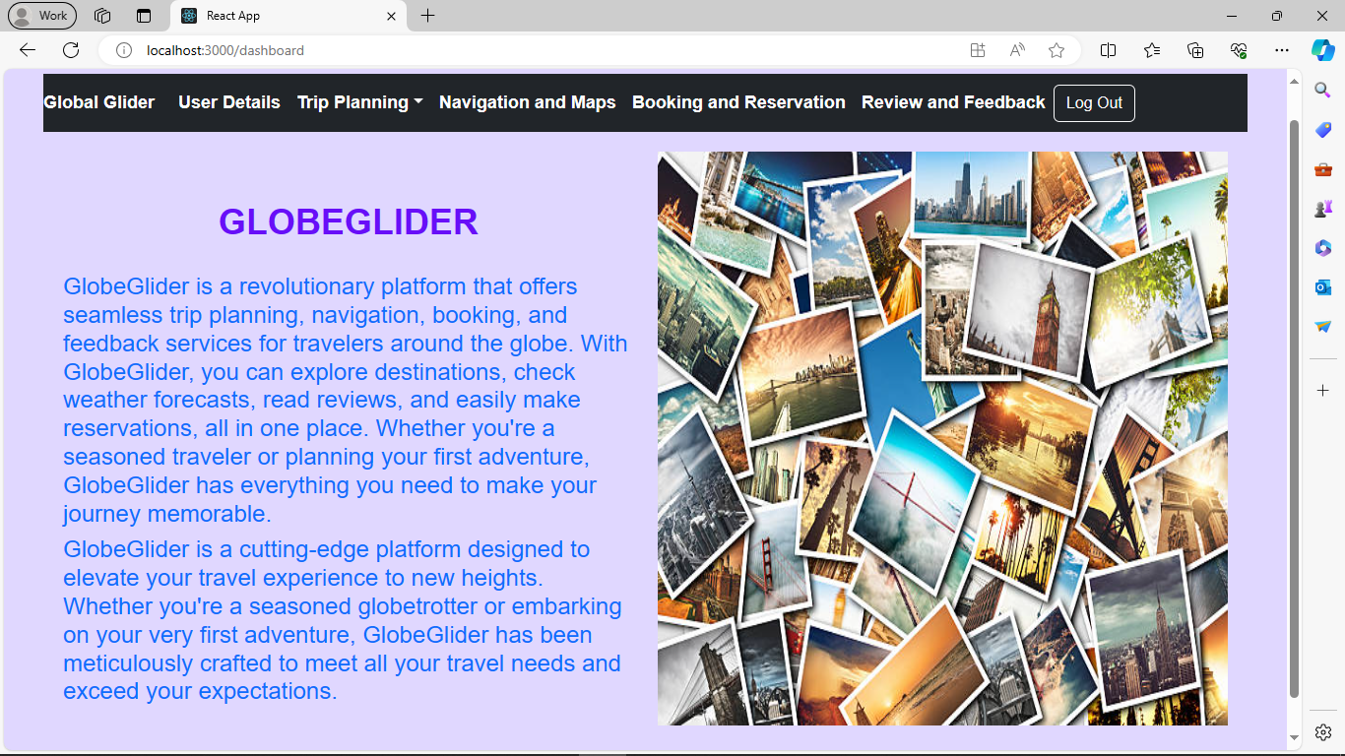

USER DETAILS:

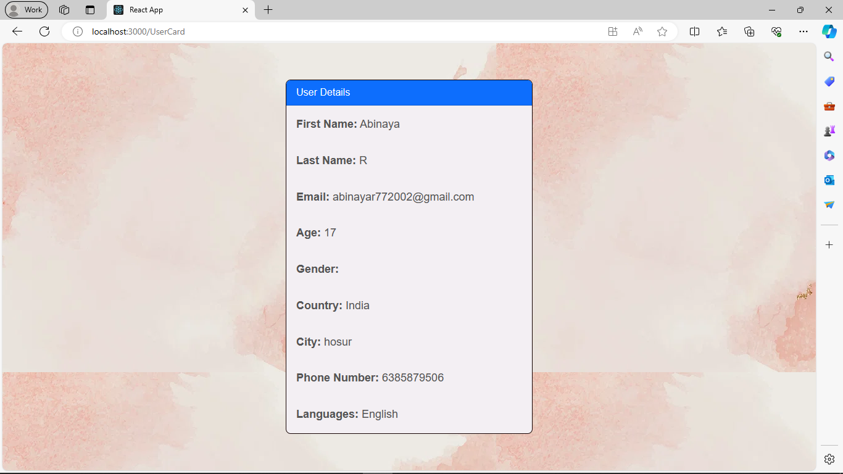

WEATHER FORECAST

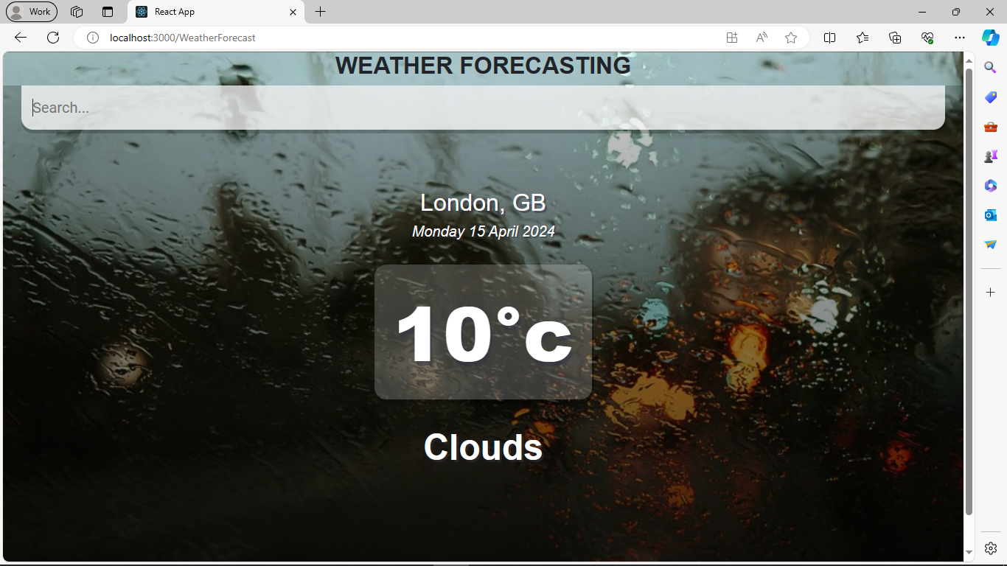

DESTINATION REVIEW:

DESTINATION IMAGES:

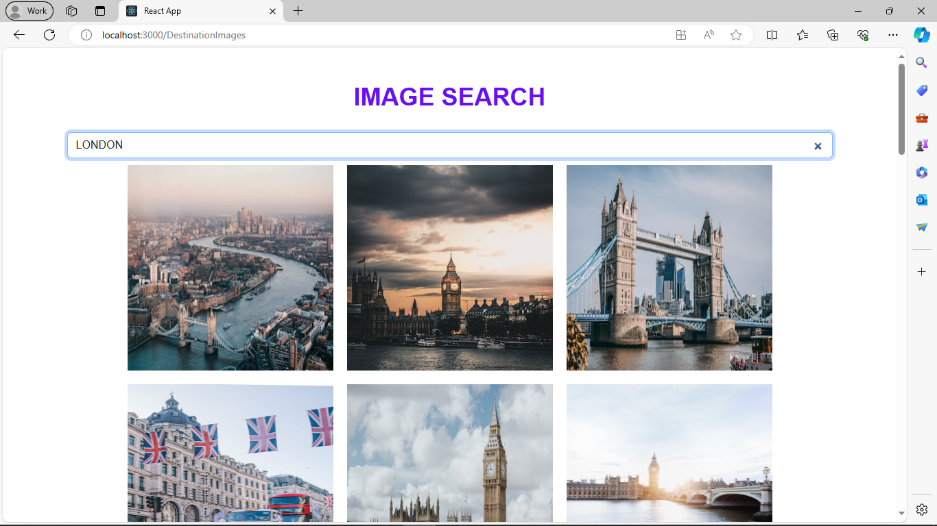

NAVIGATION AND MAPPING

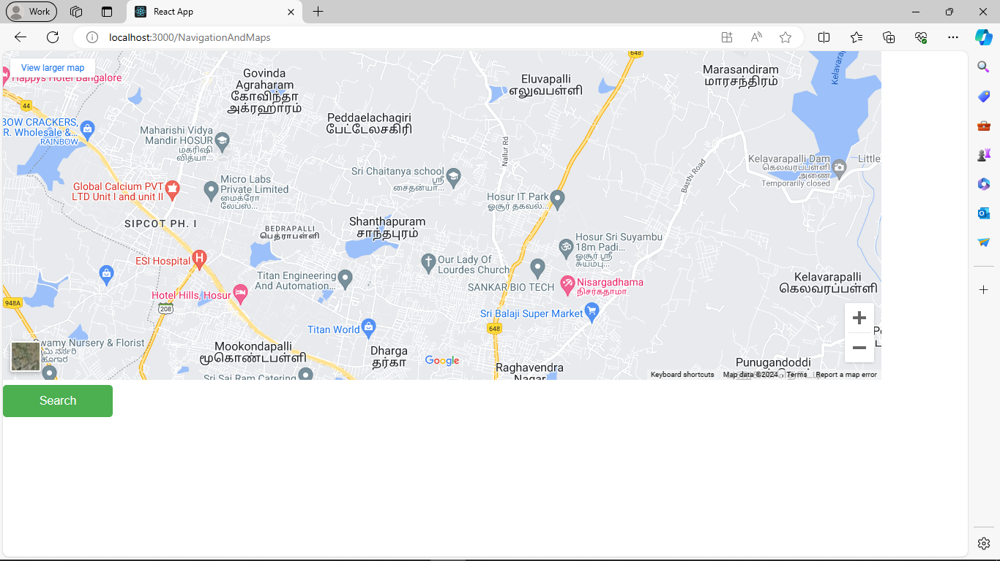

BOOKING AND RESERVATION

REVIEW AND FEEDBACK FORM

**CONCLUSION:**

GlobeGlider is more than just a travel app – it's a personalized guide that transforms your journeys into seamless and unforgettable adventures. By combining user-friendly features, customization options, and a vibrant community platform, GlobeGlider makes exploring the world easy and enjoyable. Whether you're a seasoned traveler or a first-timer, this app is designed to enhance every aspect of your trip, from planning to sharing your experiences. With GlobeGlider, the joy of discovery is at your fingertips, connecting you with a global community of fellow explorers and turning your travels into lifelong memories.

**REFERNCES:**

* [**https://react.dev/**](https://react.dev/)
* [**https://www.w3schools.com/REACT/DEFAULT.ASP**](https://www.w3schools.com/REACT/DEFAULT.ASP)
* [**https://legacy.reactjs.org/**](https://legacy.reactjs.org/)
* [**https://react-bootstrap.netlify.app/docs/components/cards/**](https://react-bootstrap.netlify.app/docs/components/cards/)
* [**https://legacy.reactjs.org/docs/forms.html**](https://legacy.reactjs.org/docs/forms.html)
* [**https://razorpay.com/**](https://razorpay.com/)
* [**https://react-bootstrap.netlify.app/**](https://react-bootstrap.netlify.app/)
* [**https://react-bootstrap.netlify.app/docs/components/navbar/**](https://react-bootstrap.netlify.app/docs/components/navbar/)